SCIENCE Semester 1 Practice exam TWO /54

1. Four cars A, B, C, and D are moving on a levelled road. Their distance versus time graphs is shown in the adjacent figure. Choose the correct statement.
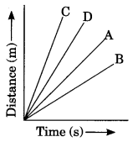
(a) Car A is faster than car D.
(b) Car B is the slowest.
(c) Car D is faster than car C.
(d) Car C is the slowest.

2. Which of the following is a correct measure of velocity?
(a) 30 s
(b) 30 m/s
(c) 30 South
(d) 30 m/s, South

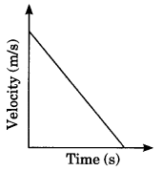
3. The velocity-time graph of an object is given below. The object has

(a) Constant velocity
(b) Constant speed
(c) Constant acceleration
(d) Varying acceleration

4. Velocity is defined as _____ per time.
- distance
- displacement
- power
- acceleration

5. What is the net force on an 800-kg airplane flying with a constant velocity of 160 km/hour north?
a. zero
b. 160 N
c. 800 N
d. 128 000 N

6. The same net force is applied to object A and object B. The observed accelerations of the two objects are not the same; object A has an acceleration three times that of object B. Which of the following is correct?
a. Object A has three times the mass of object B.
b. Object A has one-third the mass of object B.
c. Object A has a different, less streamlined shape than object B.
d. Object A has more friction than object B.

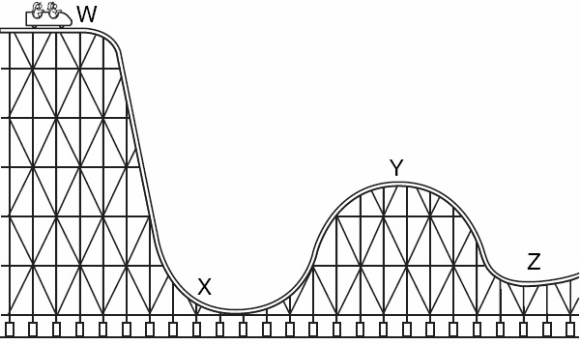
7. In the diagram of the rollercoaster on the right, at which point is potential energy greatest?
- W
- X
- Y
- Z

8. The significance of valence electrons in an atom is that valence electrons…
- Are equal in number to the protons in the nucleus
- Are the innermost ring of electrons around the nucleus
- Determine the chemical reactivity of the atom
- Are the electrons lost by the atom in a chemical reaction

9. The alkali earth metals are:
- The rarest of metals
- Group 1 on the periodic table.
- Metals which lose two electrons in chemical reactions with non-metals
- The most reactive metals in the periodic table

10. The chemical formula for calcium sulphate is
- Ca²⁺SO₄²⁻
- Ca₂(SO₄)₂
- CaS
- CaSO₄
(10 marks)

11. In a science lesson, some children float an apple on some water. One of the children says:
"The apple is not moving. That means that there cannot be any forces acting on it."
Do you agree? Explain your answer as fully as you can.

(2 marks)

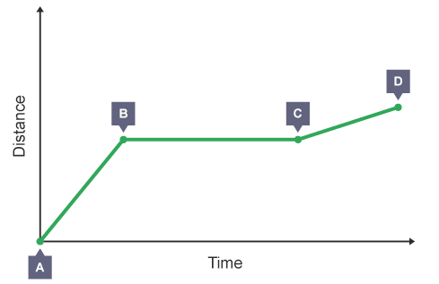
12. The graph shows the distance a person walked on a short journey.

In as much detail as you can describe the journey of the person

(3 marks)

13. A car travels 65 km in a northerly direction and then turns East and travels 25 km. the entire journey takes 1 hour. Calculate
a. the speed of the car.

(1½ mark)
b. The velocity of the car in metres per second

(2 mark)

14. A motorbike accelerates from rest at 2.8 m/s/s for 11 seconds.
- What is the final velocity of the motorcycle?

(1½ mark)

- What is this velocity in km/hr?

(1 mark)

15. A trolley with a mass of 200 kg collides into a wall and accelerates (negatively) at -25 m/s/s. What was the force with which the trolley hit the wall?

(1½ mark)

16. Use your knowledge of Newton’s first law of motion to explain why it is dangerous to leave heavy objects lying unsecured (not tied down) in the back of a car.

(3 mark)

17. A 500 g ball is dropped from a 75 metre building. What will be its velocity when it hits the ground?

(3 mark)

18. Write definitions for
- Molecule
- Noble gases
- Atomic number
(3 mark)

19. State the law of conservation of matter

(1 mark)

20. For each of the reactions below identify the TYPE of reaction it is and balance the chemical equation.
  - __________________: ___ Fe + ___ O₂ → ___ Fe₂O₃
  - __________________: ___ Pb(NO₃)₂ + ___ K₂(CrO₄) → ___ PbCrO₄ + ___ KNO₃
  - __________________: ___ H₂ + ___ N₂ → ___ NH₃
(7½ mark)

21. Write a balanced chemical equation for a double displacement reaction between Sodium chloride and Aluminium hydroxide.

___________ + ___________ __________ + ___________

(4 mark)

22. Explain how temperature and surface area can change the rate of a chemical reaction.

- temperature
- surface area

(4 marks)

23. A student performed an experiment in which they investigated if changing the temp of a reaction affects the rate of a reaction. The reaction investigated was magnesium metal reacting with hydrochloric acid. The reaction produces hydrogen gas, so the rate of the reaction was measured by how quickly hydrogen gas was produced. The student did the experiment at three different temperatures; 25⁰C, 65⁰C, and 80⁰C. the results of the reaction are shown below in the table.

Time (s) | Volume of hydrogen gas produced (cm³)
 | 25°C | 60°C | 80°C
0 | 0 | 0 | 0
10 | 17 | 32 | 31
20 | 30 | 46 | 50
30 | 39 | 57 | 60

- List the independent and the dependent variables for the reaction.

(2 marks)
- Describe, in one sentence, the relationship between temperature and the rate of reaction which is shown in the data within the table..

(2 marks)
- List two variable which would have been controlled by the student during this experiment.

(2 marks)

HARDER: A car with a mass of 1.2 tonnes accelerated from 1.5 m/s to 12.3 m/s in 6.5 seconds. What net force was being applied to the car to generate this acceleration?

